Symbology—how ArcMap draws a layer in a project.

Layer—the reference, in ArcMap, to a data set.
Exploring the reefs
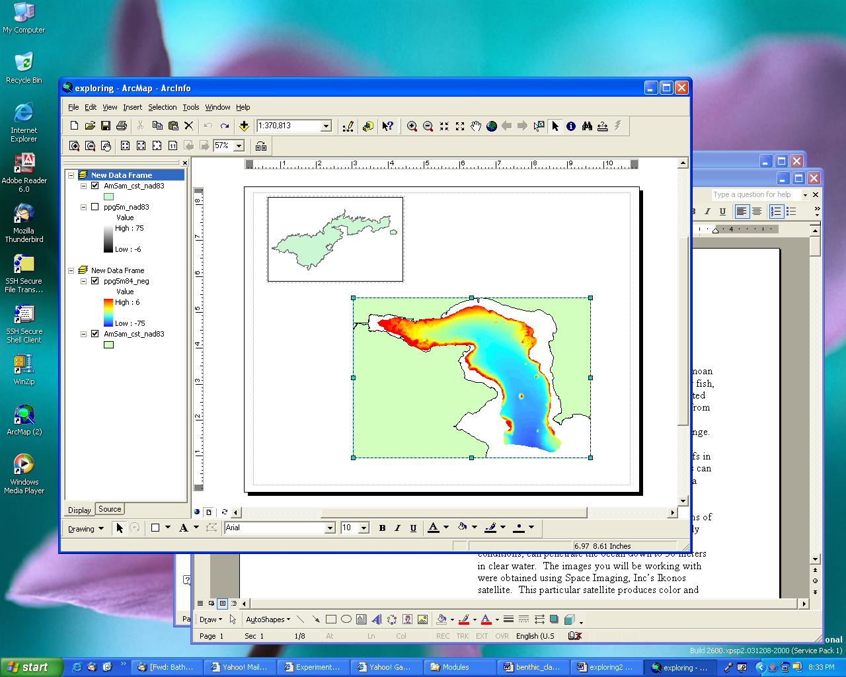
Introduction

Coral reefs surround many of the islands in the Samoan Archipelago. Many people depend on the reefs for fish, shellfish, etc. Coral reefs depend on clear, unpolluted water for survival. They face a number of threats from various problems such as pollution, sedimentation, destructive fishing methods and global climate change.

Until recently, little was known about the coral reefs in American Samoa below the point to which humans can dive. In 2001 and 2002, seven areas around Tutuila were surveyed between 2 m and 150 m in depth).

In this lesson, you will explore portions of the reefs around Tutuila using two types of remotely sensed imagery. Satellite imagery, in clear water, can penetrate the ocean down to 30 m. The images you will be working with were obtained using the Ikonos satellite. This particular satellite produces color and color infrared images with up to 4-meter resolution.

Objectives

On completion of this lesson, you should be able to:

- Add data to an ArcMap project.
- Define metadata and explain its use.
- Change the symbology for a layer.
- Measure objects in an ArcMap project.
- Identify features in an ArcMap project.
- Make a layout.
- Explain what factors affect the quality of a satellite image.

Working with the Data

Ikonos imagery is obtained from the Ikonos satellite. The colors of the imagery are separated into bands (the imagery you will be looking at has 3 bands that appear in ArcGIS: red, blue and green). The red band does not penetrate water very well, but the blue and green bands can penetrate ocean water up to 30 meters in good conditions. Water clarity, pollution and waves
(Note: multiple files may be added by holding the Shift key while clicking on file names).
1
2
10
7
4
8
2
5
4
Figure 1—A Sample Grid of depth values

Note on Buttons and Tools: There is a difference between a button and a tool in ArcGIS. When you click on a button, something happens without any other action on your part. For example, when you clicked on the 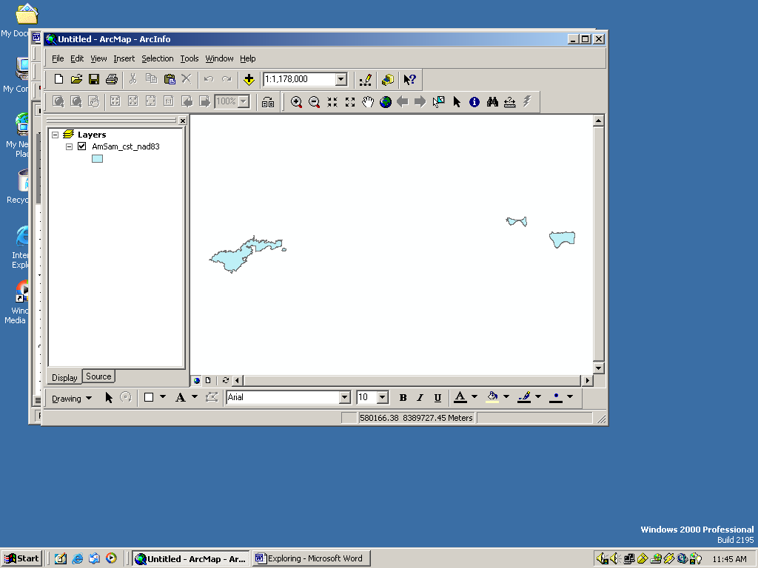 add data button, a file window appeared. There is also a zoom in button: . The button zooms in on the map when it is clicked. When you click a tool, however, nothing happens until you do something on the map. The zoom in tool requires you to click on the map and draw a box before it will zoom in closer on the map.
can all affect how deep the imagery can detect. Color Ikonos images have a resolution of 4 meters.

Loading the data
1. Open ArcMap. Click the add data button (or go to File -> Add Data).

2. Navigate to the directory where the data are stored. To do this you will likely have to click on the connect-to-folder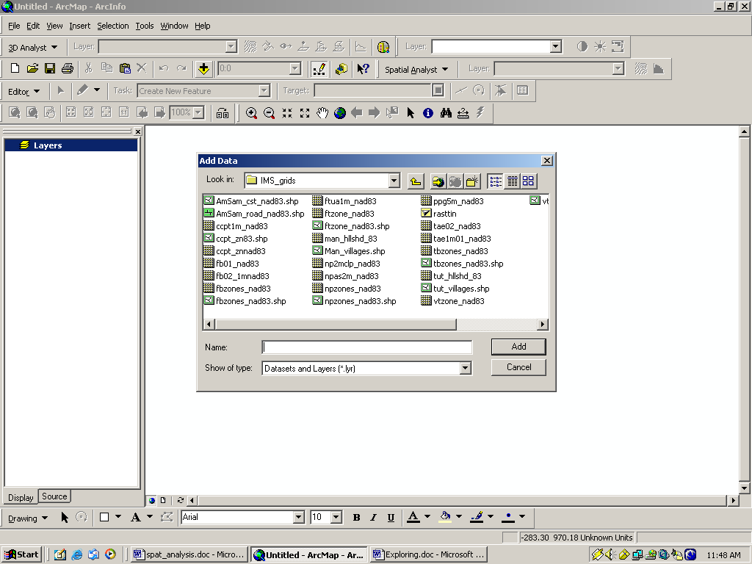 button. Choose the correct folder and click Ok.

3. Choose the file named tut_color16.img and click ok. It may take it a few minutes to load…be patient.

Exploring the data—Ikonos

1. Metadata: To find more information about the Ikonos image of Tutuila, you need to look at the metadata. Open My Computer and navigate to where the data are stored. Open the file tut_color_16.img.xml using Notepad or another text editor. This file is an example of metadata. Metadata is basically a file that tells more information about a GIS data file. Some information that may be contained in a metadata file includes date the information was obtained, resolution, projection, geographic coordinates and where the data originated. Without metadata, many files would not be useful.

- What is the resolution of the image (hint: it is a multi-spectral image)?
- How many original images were tiled (pieced together) to produce the image of Tutuila?
- Who created the image?
- When was it created?

2. Go back to ArcMap. Zoom in to Pago Pago International Airport using the zoom in tool. Click on the zoom in tool. Now, while holding the mouse button down on the map, draw a box around the area you want to see in more detail. Using the measure tool, find the length of the longer runway at the airport.

Note: Use the Full Extent button to return to the view of the whole island.

Click on the measure tool 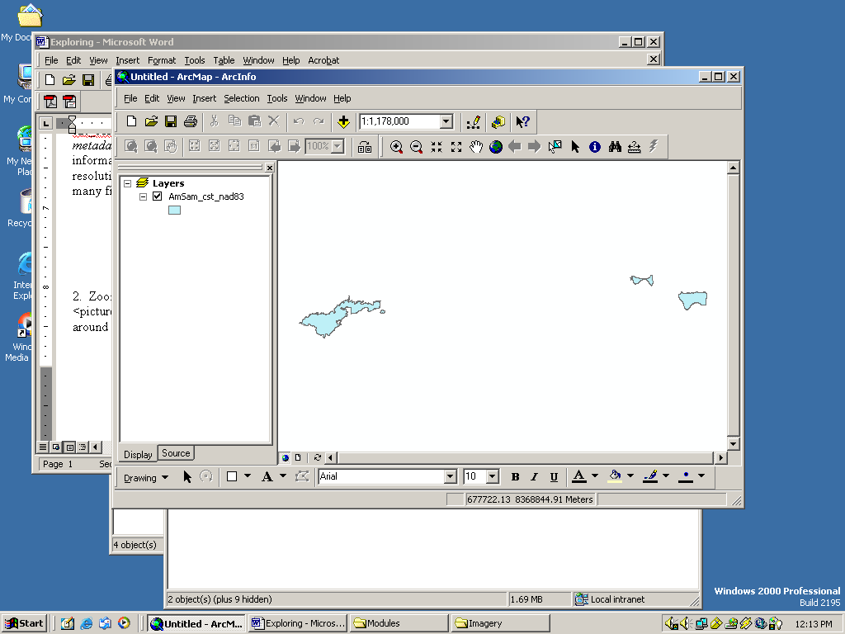, then click on one end of the runway and double-click on the other end. The measurement will be shown in the lower left hand corner of the ArcMap window: 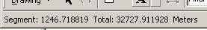.
Fagaitua Bay
Fagatele
Bay

- What is the length of the long runway at Pago Pago International Airport?
- What is the length of the long runway at Pago Pago International Airport in feet?
  - Right Click on Layers→Properties.
  - Click on the General tab and change the Display pulldown menu to show feet.
  - Change the display back to meters once you have the answer.

3. Ikonos imagery can penetrate the ocean down to 30 m in clear, smooth water. Zoom in to Fagaitua Bay on the southeast side of Tutuila (see map). The water in this image appears dark. Notice the dark triangle-shaped area in the shallow part of the reef. This area was dredged at one time and has since been re-colonized by coral.

- What are the white blotches around the shallow parts of the reef?
- How many channels (‘ava) leading from the shallow part of the reef out to sea can be seen in Fagaitua Bay?

Zoom in to Fagatele Bay (see map) on the southwest end of Tutuila.

- Why isn’t this part of the image as useful for looking at the seafloor as the image of Fagaitua Bay?
- What is causing the water to be less transparent than the water in Fagaitua Bay?

Zoom in to Pala Lagoon (just north of Pago Pago Airport).

- Why is the water in the lagoon red?
- Would you expect to find coral here? Why or why not?
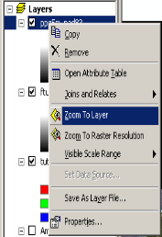
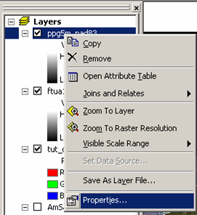
Turn off the Ikonos image of Tutuila by clicking in the check box next to the layer name.
Figure 2
Figure 3

Exploring multibeam bathymetry

Bathymetry is the underwater version of topography. A bathymetry grid is made up of cells, each with a value equivalent to the depth of the ocean at that point (Figure
1
8
3
2
9
7
6
7
4
Figure 1—a sample grid showing depth values.
1). The real-world distance covered by one side of a pixel is the resolution of the grid. For example, the grid you will be working with today has a resolution of 5 m. That means that each side of a square pixel in the grid is equivalent to 5 m on the ground. Multibeam bathymetry can be used for depths of a just a few meters to over 1000 m.

Multibeam surveys works similar to a fish finder. A pulse of sound is bounced off of the ocean floor and the time it takes to return to the ship is measured. In general, the longer it takes for the sound pulse to return, the deeper the ocean is at that point. The resolution of the multibeam bathymetry grid used in this lesson is 5 meters, but in later lessons, bathymetry grids with resolutions of 1 meter will be used. Unlike satellite imagery, multibeam sonar is not a picture of the seafloor. It starts out as simply a collection of return times for the sound pulses. It is then processed to produce a bathymetry grid, a collection of depth values for the ocean floor.

1. Add ppg5m84_neg and AmSam_cst to your project (see p. 1 to remember how to do this). Right click on ppg5m84_neg in the Table of Contents (Figure 2). Choose Zoom to Layer from the options.

2. Changing layer display: Right click on ppg5m84_neg in the layer list again. This time choose Properties (Figure 3). Click on the Symbology tab (Figure 4). For this layer, the most appropriate way to display the information is Stretched, which should already be chosen. The color of the display can be changed in the Color Ramp box. Choose the color bar that goes from red to blue. Bathymetry is often shown using one that starts with red for shallow areas and ends with blue for deep areas. If the color bar is reversed (red for deep values), check the Invert box.
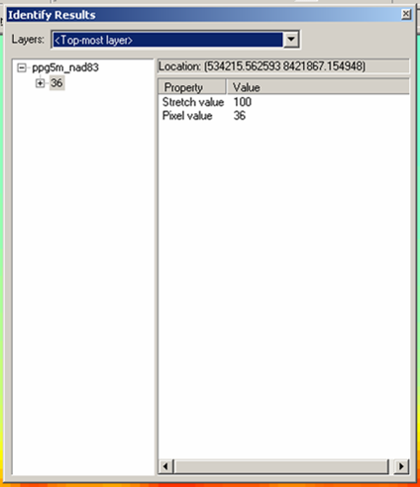
Figure 5
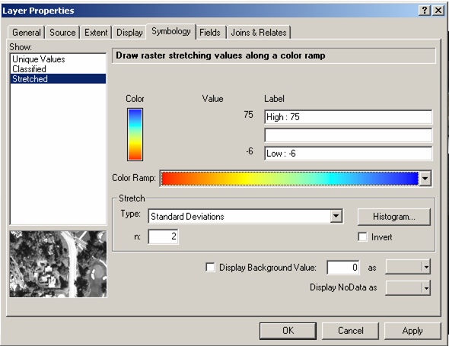
3. Exploring the multibeam data. The Identify tool 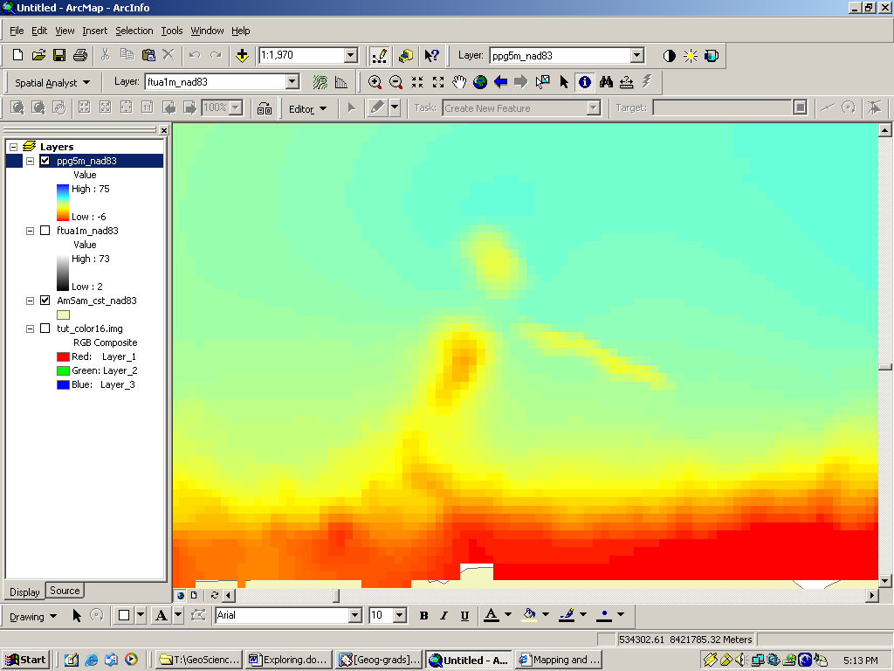 can be used to learn more information about an area. First, make sure the ppg5m84_neg layer is active. Do this by clicking on the name of the layer once, so that it is highlighted. Now click on the Identify tool and click somewhere on the ppg5m84_neg grid. The Identify Results window will appear with information about where you clicked in it (Figure 5). The pixel value in the Identify Results window shows how deep the place where you clicked is, in meters. Click on different areas to compare depth values in different parts of the harbor.
Figure 4

4. Another way to learn more about a grid is to look at the statistics for it. Right-click on the name of the Pago Pago Harbor grid and go to Properties. Click on the Symbology tab if it is not showing. Click on the Histogram button 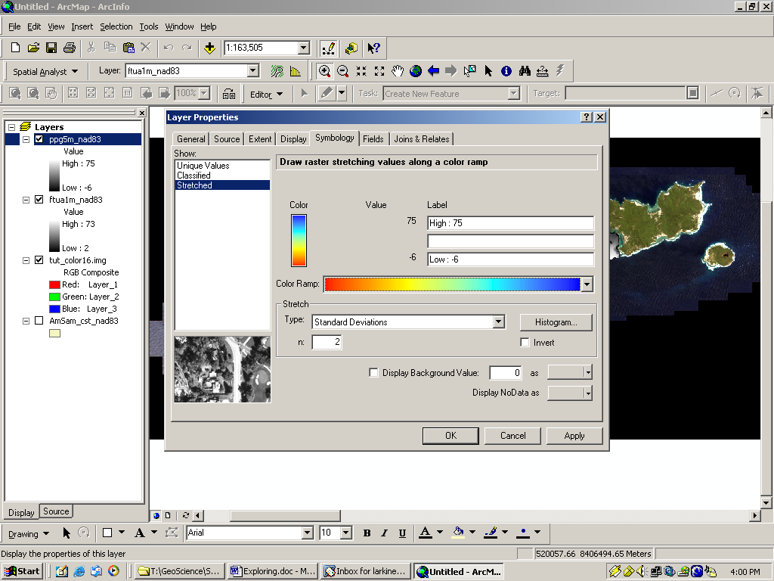 . This will bring up the Histogram window.

a. What is the maximum depth in Pago Pago Harbor?
b. What is the mean depth in Pago Pago Harbor?

5. Zoom in to the northern half of Pago Pago Harbor. The World War II tanker, Chehalis, sunk in Pago Pago Harbor in 1949. This wreck is visible from the multibeam bathymetry. Zoom in to the area circled
Figure 5

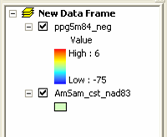
Figure 7

Note: A new toolbar will appear in the layout view: the layout toolbar. 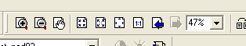 If you want to zoom in or move around on the layout, it is important to use this toolbar, rather than the map toolbar. If you use the map toolbar, your layout will change in unexpected ways.

along the south side of Pago Pago Harbor (Figure 6). Zoom in close enough that you can see all three features. The long straight feature is the wreck of the Chehalis.

Visit the following web pages to answer questions c-e: http://www.history.navy.mil/danfs/c7/chehalis.htm and http://dusk.geo.orst.edu/esri02/.
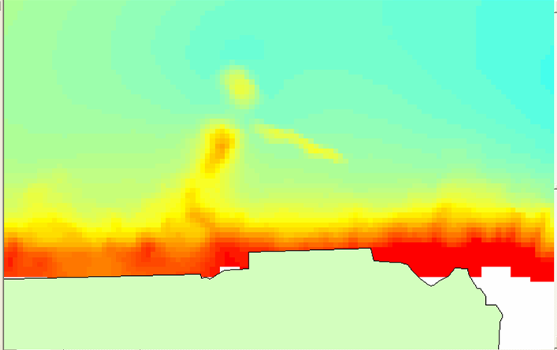
Figure 6
- How long is the wreck, in meters?
- How deep is the wreck?
- How did the Chehalis sink?
- What was she carrying?
- Is the Chehalis still a concern for pollution in the harbor? Why? (hint: think about what the ship was carrying).

Making a Layout

Printing maps from ArcMap requires making a layout.

  - Zoom out so the map shows all of Pago Pago Harbor. Add the AmSam_cst layer. This is a polygon shapefile showing the coast of American Samoa. You can change the fill color by clicking on the color under the layer name in the layer list (figure 7).

  - Go to File → Page Setup and change the page orientation to Landscape. Make sure the page size is 11 x 8.5.

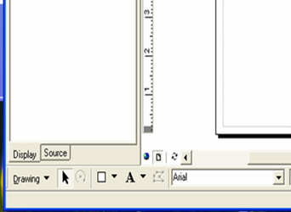
Figure 8

Note: The faint line around the edge of the page shows where the printable area is. Do not put anything outside of this line or it will be cut off by the printer.

Note on Text Size: The title should be the largest text in your layout. Your name and date should be smaller and less prominent. The north arrow and scale bars should be large enough to be easily read.
  - Click on the layout button in the lower left hand corner of the map frame (figure 8). The map frame will change to show a piece of paper and the part of your map that was visible in the map frame.

  - It is common to include an inset map to show a more general location of the map. To do this, go back to the map view.

    - Go to Insert → Data Frame.

    - Add the bathymetry file and the coast file to the new data frame just as you did earlier. Zoom in to the Tutuila. You may want to change the colors of both files, which is also done just as you did earlier.
    - After you are happy with the colors, go back to the Layout View. There will be two maps there now, although they may be on top of each other. Click on the map of Tutuila and move it to the upper right or left corner of the page.

    - Place the map of Pago Pago Harbor where you would like it. You can change the size of the image by clicking on a corner and dragging it larger or smaller.

  - There are a number of important things that should be included on a map:

    - Title
    - Your Name
    - Date
    - North Arrow
    - Scale Bar
    - Neatline
    - Legend

  - The processes to add a title, name and date are all similar.

    - Go to Insert → Title. A text box will appear on the map. Type your title in the box. It probably is not a font and size that looks good, so click off of the text box. To edit the style of the text, double-click on the text or right-click

Note: Sometimes ArcMap will not make the changes you make in the Symbol Selector window. If this happens, you will have to go back and make the changes again.
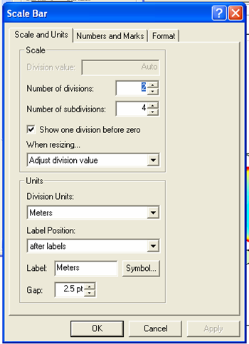
and choose Properties. A window will appear with various options. You can edit the text itself in the box under the Text tab.
Figure 9

      - Click on the Change Symbol button to change the style of the text. This will bring up the Symbol Selector window with various font options. On the right side of the window is a box labeled Options. You can change the font, font size and appearance here. When you are done, click Ok.

      - One other thing you may want to change is the justification of the text. This is how the text is aligned: left, right or center. This is done in the Properties window just under the text box.

      - To move the Title, click once on the text. Arrows will appear; click and drag the text to where you want it.

    - To add your name and the date, go to Insert → Text. A text box will appear and can be edited and moved in the same way that you made changes to the title.
  - To add a North Arrow, go to Insert → North Arrow. The North Arrow Selector window will appear. Pick one that suits you and click Ok. The North Arrow can be moved in the same way that you moved text. To change the size of the North Arrow, click on one of the corners and drag it to make it bigger or smaller.

  - To add a Scale Bar, go to Insert → Scale Bar. The Scale Bar Selector window will appear. Choose a scale bar style and click the Properties button, making the Scale Bar window appear. Make sure the units are in something that makes sense, such as meters, kilometers or miles and click Ok (Figure 9). Click Ok again. The scale bar can be moved in the same way text is moved. To resize it, click on one of the handles and drag it to a new size.

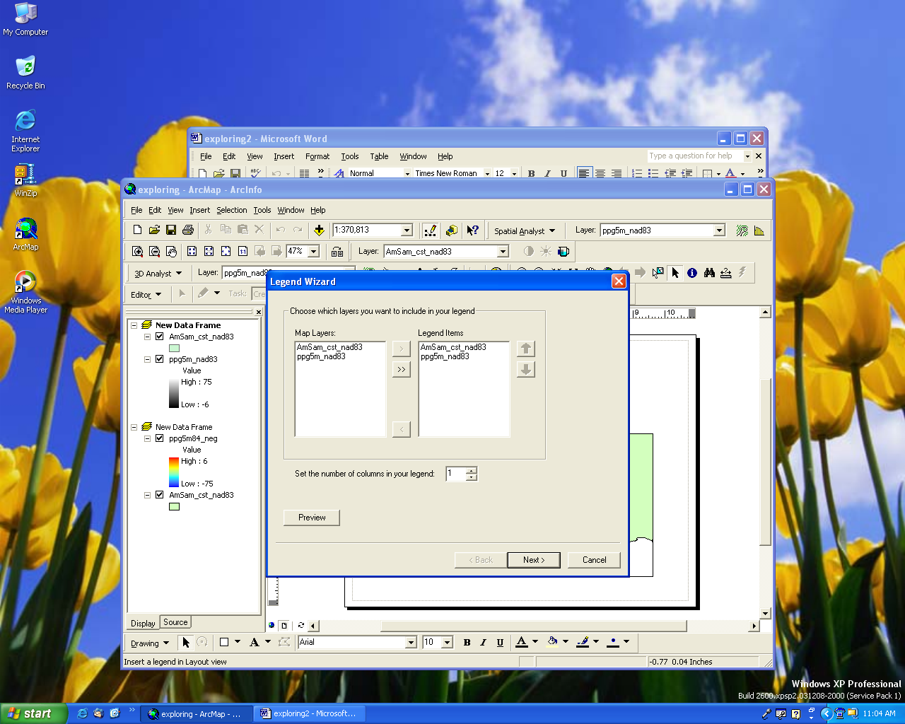
Figure 10

Note: You can edit your legend after it appears by right-clicking on it and choosing Properties.

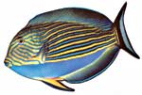
Courtesy NPSA
  - Adding a neatline: Go to Insert→ Neatline. The Neatline window will appear. Choose the Place Inside Margins option. In the Borders pulldown menu, choose a neatline that you like. In the Background pulldown menu, choose Hollow (meaning “No Fill”). Click Ok.

  - The last thing you need to add is a legend. Make sure your map data frame is activated, NOT the inset map (To activate a data frame, right-click on it and choose Activate.). Go to Insert→Legend. The Legend Wizard will appear (Figure 10). Click Next twice.

    - On the Border Options screen, choose a border you like from the pulldown menu.

    - Click Next twice and the click Finish.

    - The legend will probably appear in an odd place such as directly over your map. It can be moved around and resized in the same manner as text or the north arrow.

  - Make sure everything on the map lies within the neatline (i.e. nothing touches or falls outside the neatline.). When you are happy with the map, print a copy to turn in.

National Park of American Samoa Fish Inventory

Go to the National Park of American Samoa (NPSA) Fish Inventory (http://www.nps.gov/npsa/NPSAfish/). Choose to different species of fish and answer the following questions about them. You may need to search for their scientific, English or Samoan names on Google and look at a several sites to find out more about them.

- What are the scientific, English and Samoan names for the fish you chose?
- Where do they live? (on the reef? deep ocean?)
- What type of habitat do they prefer? (under rocks? open water?)
- What do they eat?
- Are they fish that you have seen, either in the water, at the market, or a fish you have eaten?
- Are they threatened species? If so, why are they threatened and what is being done about it?

Additional Questions

- If a satellite image has a resolution of resolution of 5 m, would it be possible to tell apart two cars parked next to each other (about 1.5 m apart)?

- What is the coarsest resolution imagery that could be used to distinguish features that are 20 m apart?

What to turn in:

- Answers to the questions.
- Your layout from the second part of the lab.

